Northern Dutchess Rod and Gun Club
With: Russell Farms
Pancake Brunch and
Maple Syrup Demo.
Club Open House
For Info Call: 845-876-3711

Saturday April 6, 2024
9:00 am till 1:00 pm

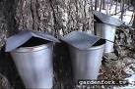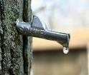
Adults and older children $ 10,
Children 10-5 $5, under 5 and scouts in uniform free

Maple tapping and Syrup demos on the half-hour, Russell farms products available for purchase
Club Address: 140 Enterprise Rd., Rhinebeck, NY
From the junction of Rt. 9 and 308 in Rhinebeck, take 308 East to Salisbury Tpk (County 52). Make a right on Salisbury Tpk, then a right on Enterprise Road to Northern Dutchess Rod & Gun Club on the right side of the road. From the Bull's Head Road exit from the Taconic State Parkway head West to Eighmyville Road, make a right, then bear left onto Enterprise Road. The club is on the left.

